Blurb: “This quiz is gauge students understanding in areas relating to variable assignment, and students ability to visualise these concepts”

Question 1: How confident are you in visualising fields vs methods?

Question 2: How well can you visualise the difference between variable type and an object instance?

Question 3: How confident are you in visualising the following code snippet?



Question 4: How confident are you in visualising the following code snippet?

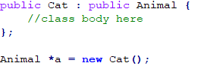

Question 5: How confident are you in visualising the following code snippet?

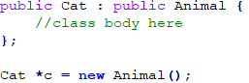

Question 6: How confident are you in visualising the method call in this code snippet?

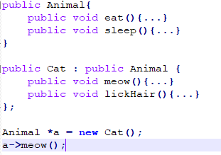

Question 7: How confident are you in visualising the method call in the following code snippet?

